DevopsNinja: AWS IAC Project

Pre-Requisites:

* Lab-server with ubuntu OS, Admin Access role for performing terraform actions and terraform installed.

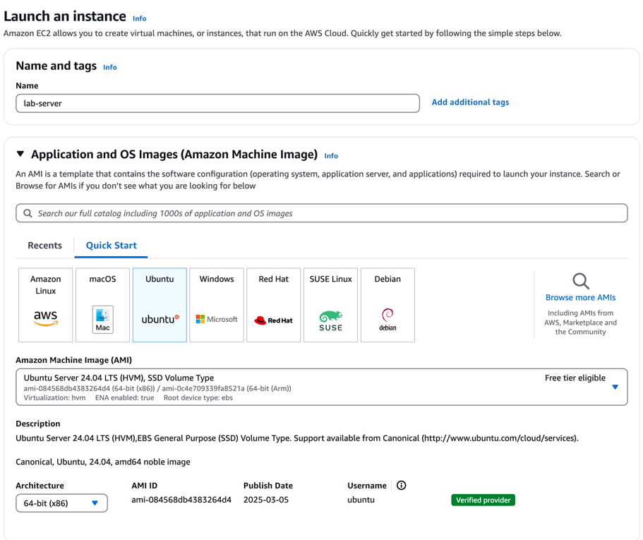

* Clone git repo and follow instructions.md under project

https://github.com/htpractice/ht-practice-work.git

Task 1: Setting up infra and backend

* ECR to store images created
* Bastion
  + Linux -> to ssh the app and Jenkins host while acting as ansible controller
  + Windows -> to connect Jenkins private LB
* ALB
  + Jenkins Private ALB
  + Movie-App Public ALB

Subtask1:

* Ensure AWS CLI is installed and configured with full access in your Linux machine.
* Initialize a bucket in s3 for the backend state store using Terraform. This bucket will be used later in this project to use the state files of Terraform.

Solution:

* AWS CLI installed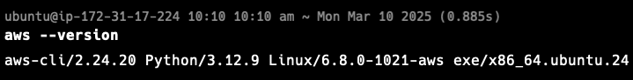
* S3 bucket created
  + Repo: - <https://github.com/htpractice/ht-practice-work.git>



Subtask2: Network Setup

Solution:

* Network Resource Flow

* Instances and Security Groups

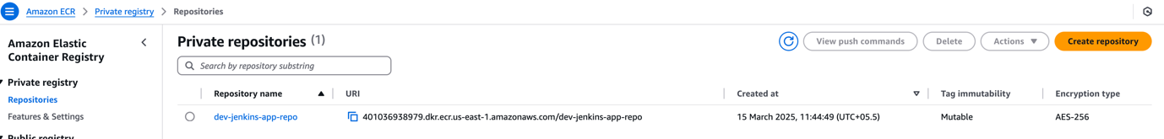

Use of dynamic inventory

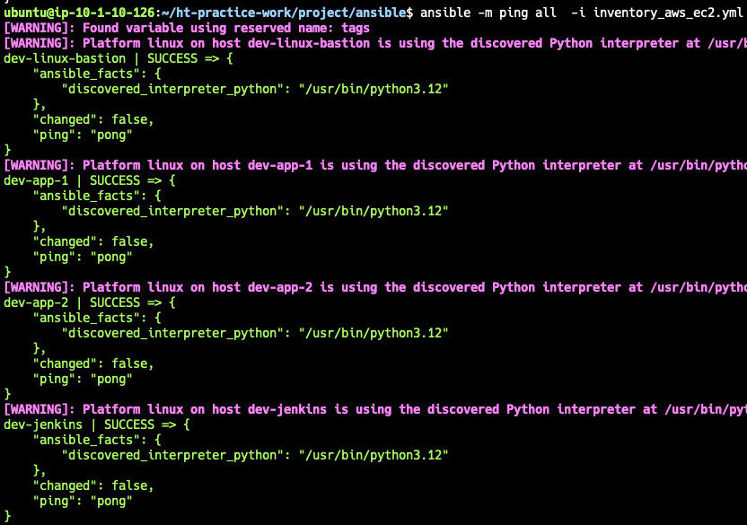

Jenkins instance login from bastion

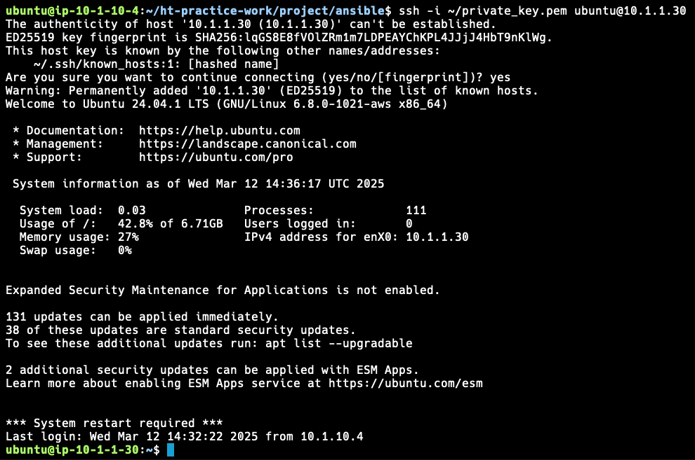

Jenkins image

Running Jenkins as /jenkins



Connection to Jenkins from private lb from windows bastion

ECR Login from Jenkins



SSH from Jenkins to APP

SSH from Jenkins Job to APP

Configure Jenkins and project pipeline

